**Analyzing the Impact of Restaurant Features on Customer Ratings: A Machine Learning Approach.**

Mohammad Khaki1, Fereshteh Dehghani1,*

1. Department of Computer Engineering, University of Kashan, Kashan, Iran

*Corresponding Author:

Address: Kashan

Tel/Fax: +98

Email:

**Abstract**

Social networks have facilitated access to a wealth of information, which can provide valuable insights for decision-making. The study objective is to evaluate the impact of various restaurant aspects on overall customer ratings. By utilizing Zomato restaurant data, the research aids users in identifying their preferred dining establishments in unfamiliar locales. The integration of machine learning techniques is highlighted in this paper to help restaurants improve customer service by prioritizing influential parameters. For this purpose, data preprocessing is implemented to normalize numerical data and remove redundant and outlier data. Then, an augmented dataset is created through data clustering to uncover latent data structures and improve classification quality. In addition, oversampling is employed to increase the number of samples. In order to identify attributes with the strongest correlations, feature selection methods are implemented. After all, some machine learning algorithms are utilized to classify data. Notably, the Random Forest algorithm achieves an accuracy of 88%, with most detection errors occurring when the target class is misclassified as an adjacent class.

Given the similarity between neighboring classes in user recommendations, this misclassification can be interpreted as valid, resulting in a remarkable 97% accuracy improvement.

In contrast, the similarity between neighboring classes is high in user recommendations. The area under the Receiver Operating Characteristic curve guarantees the algorithm's high power and reliability.

**Keywords**: Machine Learning - Random Forest - Restaurant – Clustering – Customer ratings – Predictive modeling

# Introduction

With the increase of web-based applications and the growing ease of use afforded by smartphones, there has been a noticeable rise in online orders for essential commodities. It becomes imperative for business proprietors to ensure that users encounter an analogous shopping experience online as they would during in-person shopping interactions. Today, one of these online services that is receiving much attention is the food preparation service [1].

Automated recommender systems have revolutionized how content and business are marketed and delivered by making personalized suggestions and predictions about a wide range of large and complicated products [2]. Eventually, the existence of a criterion can help diagnose scores out of the predicted range and omit cheaters [3]. The criteria used in this paper are based on quality, price, and delivery services. However, more parameters must be considered to make the intelligent system algorithm work more effectively. According to [4], the service speed, food volume, lighting, and atmosphere of the room affect the performance. However, with the spread of the COVID-19 disease, most people stayed home and ordered their food online rather than going out, and recent years have seen an increase in the number of people ordering food online [5]. Furthermore, marketing is known to help collections grow, and one of the crucial components of marketing is studying and improving users' social influence on food applications [5]. Nowadays, restaurant classification has become increasingly important for people and businesses using the Internet to expand services [6].

Before dining out, people search websites and apps for local restaurants and choose one based on an average score. Generally, It is impossible to predict the quality or cleanliness of a restaurant by its average score. The use of personalized recommendation systems is prevalent in many online firms to improve the user experience by recognizing user preferences and suggesting relevant products. Classifying restaurants by topic facilitates creating a recommender system in machine learning [7].

Information extracted from Zomato's restaurant dataset reveals that individuals tend to rate the quality of their experience based on what they receive, irrespective of the availability of additional services like delivery. Nonetheless, the presence of this service has a significant impact on the perceived quality of the overall experience. It is critical to note that food quality is a major factor in determining customer satisfaction when ordering meals online [8, 9]. Consequently, to maintain food quality throughout online delivery, eateries should carefully consider strategies to maintain food presentation and temperature. [10].

In this paper, machine learning techniques are used to predict how restaurants will score, and each restaurant is ranked based on food quality, price, online ordering, and delivery service. The proposed paper predicts how people will evaluate a new restaurant that has not yet been rated by considerable people.

The rest of this paper is organized as follows. Section 2 provides a literature review of previous work on recommender systems for restaurant classification. The proposed classification method, which involves data preprocessing and creating an augmented data set through data clustering, oversampling, feature selection, and classification methods, is demonstrated in Section 3. Section 4 discusses the evaluation of the proposed system, and Section 5 declares the paper's conclusion.

# Related work

Some previous works have shown that restaurant customers care about the quality of the food as well as how satisfied they are with online food delivery applications [11-15]. The characteristics of customer satisfaction with restaurant delivery applications are identified in Korea. The results showed that mobility and reliability affected satisfaction and loyalty. Therefore, developers should focus on making them more dynamic and trustworthy rather than adding more information to food delivery applications [16].

|  |  |  |  |  |
| --- | --- | --- | --- | --- |
| **Ref No** | **Aim of paper** | **Methodology** | **Dataset** | **Main Conclusion** |
| [16] | Data summary | Analyze structural equation modeling | Questionnaire in Korea | Application developers should not now focus on presenting an enormous amount of information to users. |
| [6] | Multi-labeling before classification | Support vector machine | Zomato | Classy ambiance and delivery service are two criteria for classifying restaurants. |
| [17] | Feature prioritization | Analyze structural equation modeling | Questionnaire in Iran | The quality of the meal has the greatest impact on customer satisfaction. |
| [3] | Effectiveness of dummy scores and unfair scoring | Rev2 | OTC, Alpha, Amazon, Flipkart, and Epinions | Three quality metrics are employed to identify dishonest users: fairness of users, evaluation of product quality, and reliability of ratings. |
| [18] | Suggest a classifier | Naive Bayes, Support vector machine | Open Rice | The accuracy of a classification system is influenced by the relationship between the classification models and the feature options. |
| [19] | Analyze restaurants on user behavior | Recommender system | Yelp | It is effective to classify users according to their location and behavior |

A multi-label classification method was used to classify restaurants based on predefined features affecting ratings [6]. In this work, using the outputs of two classifiers applied to a different set of features, two labels, that is, delivery service and classy ambiance, are suggested for each instance by Support Vector Machine (SVM) classification. In addition, each class is assigned an integer number ranging from 1 to 5, and the dataset is Zomato. The proposed multi-label model, however, classifies instances with an accuracy of about 80% in classes without online delivery. Therefore, users receive a subset of accepted restaurants that meet their needs via the proposed method.

# THE PROPOSED METHOD

This section explains the proposed classification method. In this paper, data clustering is used for extracting additional features to enhance the performance of classification techniques by exposing the hidden structure of input data. As shown in Fig. 1, the proposed framework consists of five steps: 1) data preprocessing, 2) creating an augmented dataset by data clustering, 3) oversampling, 4) feature selection, and 5) classification. These parts are described in the following subsections.

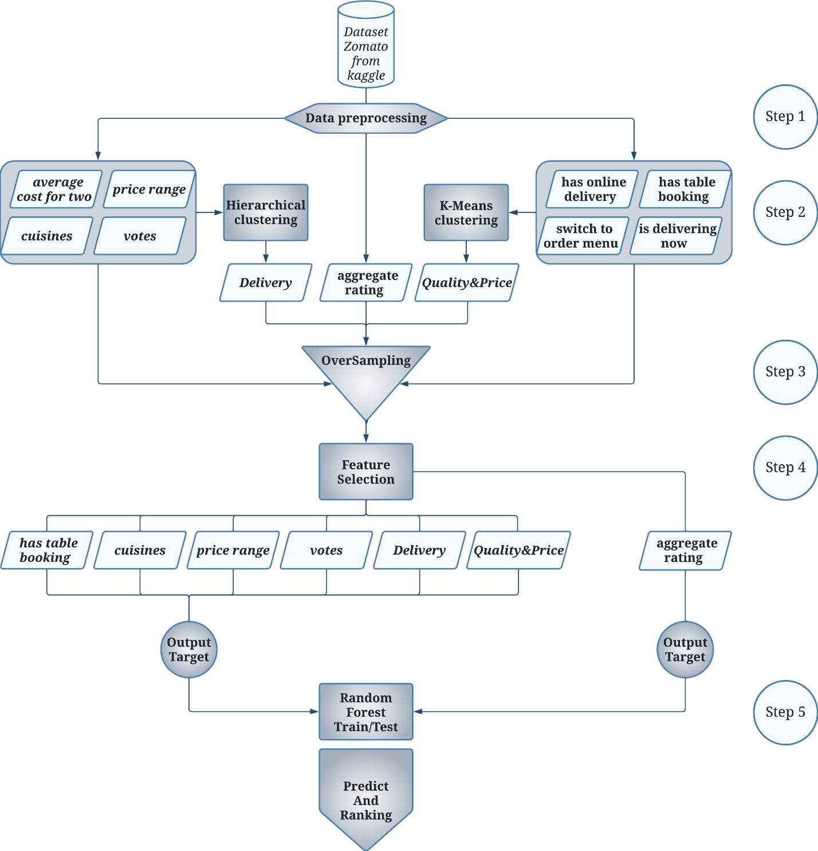

Figure . The Process Predict Model

## Data preprocessing

The Zomato dataset [20], containing the features of various restaurants, is selected in this paper, and some of the following features are selected and preprocessed. Table 1 provides a comprehensive overview of these chosen features, including their names, descriptions, and types. As detailed in the table, the hierarchical clustering approach employs features such as "Has online delivery", "Has table booking", "Is delivering now", and "Switch to order menu". The K-means approach incorporates the "Cuisines", "Average cost for two", "Price range", and "Vote" features. Additionally, the "Aggregate rating" feature assumes the target classification label. The preprocessing of these features is as follows:

1. Unify the units of the "Average cost for two" feature to dollars because of the difference in currency units.
2. Replace the string value "Cuisines" with an integer value representing the number of food types.
3. Round the multinomial values of the "Aggregate rating" feature to integers 1 and 5 to use as classification labels. The following rules are applied instead of rounding to the nearest integer to maintain the semantic distinction:

* If Aggregate rating ≥ 4.5, then "5".
* If 4.5 ≥ Aggregate rating ≥ 3.8, then "4".
* If 3.8 ≥ Aggregate rating ≥ 2.8, then "3".
* If 2.8 ≥ Aggregate rating ≥ 1.8, then "2".
* If 1.8 ≥ Aggregate rating, then "1".

1. Normalize numeric features to the standard range because of their different scales. A min-max normalization is performed on the input values to scale them between zero and one, as shown in Equation 1.

Table . Parameters of Dataset

|  |  |  |  |  |
| --- | --- | --- | --- | --- |
| Clustering method | Decision label | Feature name | Description | Type |
| Hierarchical | **Delivery** | **Has online delivery** | online order | binary |
| **Has table booking** | Online booking table | binary |
| **Is delivering now** | Ability to send food | binary |
| **Switch to order menu** | Availability of food menu | binary |
| K-means | **Quality and Price** | **Cuisines** | Food diversity | string |
| **Average cost for two** | The average cost for two people | number |
| **Price range** | Range of food Price | number |
| **Votes** | Number of comments | number |
| Response label | | **Aggregate rating** | Average user votes | decimal number |
| Auxiliary convert feature | | **Currency** | Currency | string |

## An augmented dataset by data clustering

In order to improve the quality of classifications, data clustering can be used. This theory is based on the following simple concepts: (1) grouping the training examples into clusters, (2) encoding the clusters as new features, and (3) obtaining predictions using the model that has been trained. For any classifier to be able to learn, it is assumed that classes in the dataset reflect its structure. However, this assumption may not be true in every case. Thus, it is tempting to investigate whether the use of clustering could aid the classification process by identifying the inherent, "true" structure of the dataset. Generally, if both structures (i.e., those revealed by clustering and those implied by classes) map perfectly to one another, the dataset can be classified easily. Otherwise, attributes conveying this "hidden" structure of data by clustering can contribute to better generalization of classification models [21].

As shown in Figure 1, the features are divided into two groups based on the input data type [6]. The outcomes of the clustering processes, specifically achieved through hierarchical and K-means algorithms, are labeled as "Delivery" and "Quality and Price" respectively. These resultant clusters are subsequently utilized as novel attributes for classification in the following. The "Delivery" feature, which indicates the delivery quality of a particular restaurant, is characterized by five discrete values. On the other hand, the "Quality and Price" feature, encompassing the cost-quality dynamics of food, contains a spectrum of thirteen discrete values. Finally, the clustering results and the basic features are combined as the input of feature selection algorithms to improve classification results [21]. A detailed explanation of Hierarchical and K-means clustering approaches is discussed in the next section.

### Hierarchical cluster

Two main types of hierarchical clustering are agglomerative and divisive. In this paper, divisive hierarchical clustering is used in a top-down manner, with the root containing all the datasets. Each node in a tree, such as X, is split into two children nodes containing X1 and X2, such that X = X1 ∪ X2 and X1 ∩ X2 = ∅, and so on recursively until reaching leaves. They stored data elements in singletons [22]. According to Figure 2, since the parameters of "Delivery" are binary, values are assigned based on their presence or absence. This tree has been manually constructed based on the correlation coefficients with the Aggregate Rating. As such, the attribute "Has Table Booking" occupies the root position of the tree.

* If all variables are zero, then the tree's leaf is one.
* If "Has table booking" and "Has online delivery" are zero, and one of "Delivering now" or "Switch to menu" is one, then the tree's leaf is two.
* If "Has table booking," "Has online delivery," and "Delivering now" are zero, one, and zero, respectively, then the tree's leaf is two.
* If "Has table booking," "Has online delivery," and "Delivering now" are zero, one, and one, respectively, then the tree's leaf is three.
* If "Has table booking," "Has online delivery," and "Delivering now" are one, zero, and zero, respectively, then the tree's leaf is three.
* If "Has table booking," "Has online delivery," and "Delivering now" are one, zero, and one, respectively, then the tree's leaf is four.
* If all "Has table booking" and "Has online delivery" are one, and one of "Delivering now" or "Switch to menu" is zero, then the tree's leaf is four.
* If all variables are one, then the tree's leaf is five.

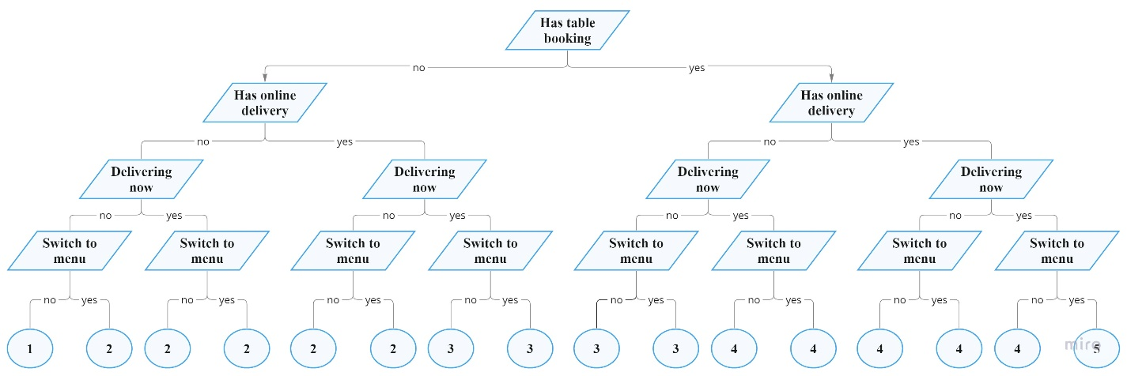

Figure . Hierarchical clustering - Class Delivery

### K-means clustering

The K-means algorithm is one of the preeminent clustering methodologies employed in data mining. In K-means clustering, a set of n observations is partitioned into k distinct clusters, wherein each observation is allocated to the cluster whose mean is closest to it [23]. The significance of K-means lies in its utility to data analysts for a dual purpose: firstly, to discern underlying simplistic patterns and operate effectively on multi-class datasets [24], and secondly, to ascertain the optimal number of clusters, thus aiding in the final determination of the clustering configuration.

This paper employs the ELBOW method [25] to determine the optimal number of clusters, yielding 13 as the preferred count for the dataset. The ELBOW method is a visual approach serving as a common heuristic in mathematical optimization. It involves the iterative calculation of cluster costs, starting with an initial value of K=2 and increasing it by one at each progressive step. The cost experiences a noteworthy decrease until a specific critical threshold of K is attained, subsequently reaching a state of stability and maintaining a relatively constant level. The point at which cluster augmentation would yield no significant improvements to data modeling. This distinctive value stands as the elected choice for K, denoting the most suitable cluster quantity.

Distances between each sample and all cluster centers are computed too and added as 13 new features (d1…to…d13) to the dataset for training. The findings indicate that whether or not this strategy is used makes no impact; however, doing so needs additional processing time.

## Oversampling

Classification systems frequently encounter the predicament of acquiring knowledge from imbalanced datasets. Consequently, strategies involving over- and under-sampling are employed in the data analysis domain to address the issue of dataset instability [26]. In the context of this paper, the Synthetic Minority Oversampling Technique (SMOTE) [27] is implemented to mitigate this concern.

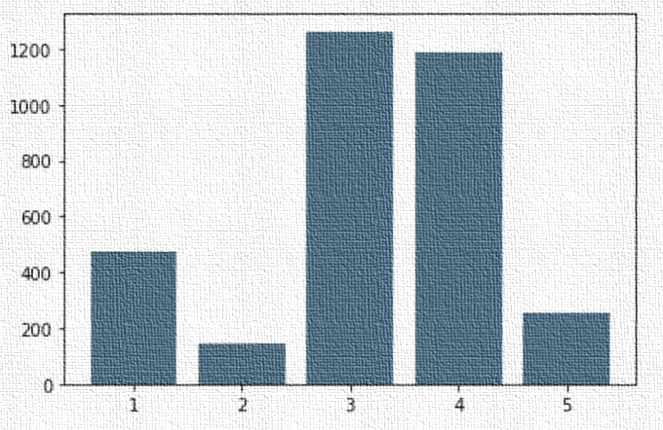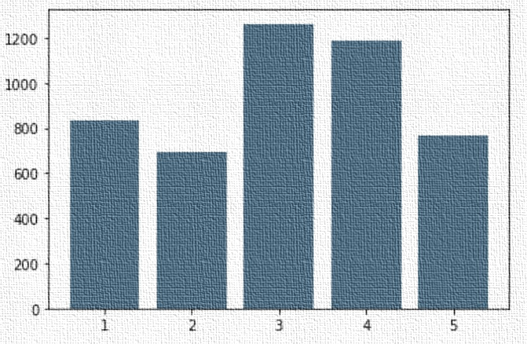As shown in Figure 3-A, the user rating dataset exhibits a concentration around the value 3, inducing a tendency for the algorithm to deviate, disregard alternative data, and yield erroneous predictions [28]. Nevertheless, Figure 3-B illustrates the used oversampled dataset, wherein the quantity of data samples in class 3 remains unaltered at its maximum count. However, the representation of class 2, initially with minimal counting, escalates to comprise 45% of the quantity in class 3. Subsequently, the population of other data instances (with ratings 1, 4, and 5) is determined proportionately based on their respective ratios. Notably, the dataset value that previously exceeded others still retains a higher representation, and its ratio is maintained to a certain extent.

Figure -A. Number of data before increasing sampling based on five user rating groups

Figure -B. Number of data after increasing sampling based on five user rating groups

## Feature Selection

After augmenting and oversampling the dataset, a feature selection procedure is employed to identify the most informative attributes for classification. The outcome of this feature selection effort encompasses a reduction in data dimensions, enhanced visualization capabilities, and an overall improvement in model accuracy [29, 30]. This paper utilizes the Sequential Feature Selection (SFS) algorithm in a forward progression. The features considered before SFS are 'Has online delivery,' 'Has table booking,' 'Is delivering now,' 'Switch to order menu,' 'Cuisines,' 'Average cost for two,' 'Price range,' and 'Vote,' in addition to 'Delivery' and 'Quality & Price.'

The SFS approach initiates with the inclusion of the initial attributes "Quality & Price" and "Delivery." At each subsequent iteration, the feature having the highest correlation with the existing feature set is added and evaluated through supervised learning. Figure 4 illustrates an upward trend in feature selection performance until the sixth feature is included. Subsequently, the performance begins to decline. Therefore, the optimal performance is based on these six attributes. As a result, the SFS algorithm returns six of the ten variables, namely 'Has table booking,' 'Cuisine,' 'Price range,' 'Votes,' 'Delivery,' and 'Quality & Price.'

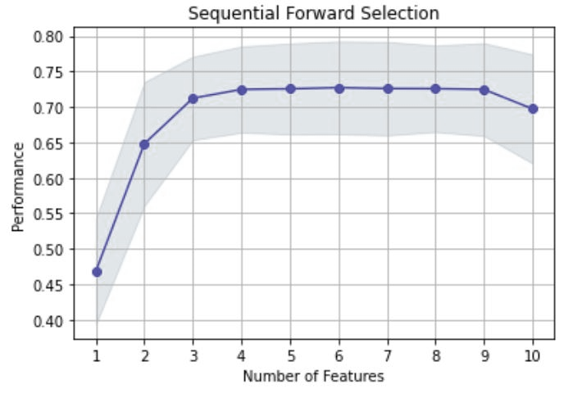 Figure . Performance of feature selection

## Supervised Classification by Random Forest Method

Some classification algorithms are employed after the feature selection process discussed in the previous section. The selected classification algorithms include a Random Forest, Support Vector Machine (SVM) with two distinct types of kernels, N-nearest Neighbors, Decision Tree, and Naive Bayes. However, as shown in the next section, the Random Decision Forests algorithm achieved higher accuracy in restaurant classification in terms of user ratings. It is categorized as a pattern recognition algorithm for supervised classification in machine learning fields and ensemble learning [31]. Random decision forests with the class most trees choose can correct the tendency of decision trees to overfit their training set. A random forest constitutes an ensemble of tree predictors where specific decision trees are integrated using adaptive bagging techniques [32].

In this algorithm, the augmented features, namely "Delivery" and "Quality & Price," along with the output of the feature selection process, collectively form the input of the classification algorithm. Moreover, the aggregate rating is the class label for each instance. When a new sample is added to the sample set, the algorithm computes the distance between the new, unlabeled instance and the cluster centers. However, the trained classifier remains applicable without modification, as the unlabelled example is in the same space as the training instances [21].

The predicted instance was treated as a probability array to increase the algorithm's effectiveness. It shows the likelihood that a sample will belong to a specific class in the classification using the best threshold or not. A prediction accuracy evaluation was subsequently carried out for each class separately.

The Receiver Operating Characteristic (ROC) curve analysis was used to identify the optimal threshold [33], which fell between 0.35 and 0.40. A True Positive Rate (sensitivity) of 0.83 and a False Positive Rate (1 - specificity) of 0.178 served as the basis for this decision.

# Evaluation

This paper used the Kaggle data repository to acquire 3324 unique instances from the Zomato Data Set. However, a combination of feature selection and oversampling techniques is employed to achieve optimal classification outcomes. Following the oversampling process, the dataset is divided into a test and training set comprising 30% and 70% of the data, respectively.

Cohen's kappa coefficient is a criterion that can better express the performance of multi-class algorithms when calculating their average accuracy. It can provide a more robust measure of model performance than accuracy alone, especially when dealing with imbalanced datasets or class distribution. The multi-class classification accuracy [34] and Cohen's kappa score [35] are represented by Eq. 2 and Eq. 3. In these equations, the True Positive (TP) and True Negative (TN) are computed instances that are correctly classified. Furthermore, instances classified incorrectly are calculated as False Positives (FP) and False Negatives (FN).

Where, Is the observed agreement (accuracy), which is the proportion of instances classified correctly. The expected agreement is the instances proportion that would be classified correctly by chance called . P_o and are obtained according to Eq. 4 and 5.

N represents the total number of instances within the dataset with class k. The number of times label k appears in the predictions is n_k1, and the number of times label k is a true label is n_k2 [36]. However, the kappa score ranges between -1 and 1. A score of 1, 0, and -1 indicate perfect agreement, chance agreement, and worse than chance agreement, respectively.

In a comparative analysis of various classifiers within the proposed method framework, several classifiers were implemented, as shown in Table 2. These classifiers were then subjected to comparison based on their respective kappa scores. Notably, the Random Forest classifier achieved a superior Kappa score, as illustrated in Table 3. Therefore, the following results utilize the Random Forest algorithm as the classifier. Table 4. Performance of supervised learning classification

|  |  |  |  |  |
| --- | --- | --- | --- | --- |
| *Supervised Classification Method* | *Kappa Score* | *Accuracy* | *Precision* | *F1_score* |
| Random Forest | 64% | 72% | 75% | 74% |
| SVM (Kernel: RBF) | 40% | 53% | 56% | 54% |
| SVM (Kernel: Linear) | 29% | 44% | 46% | 41% |
| K Nearest Neighbors | 57% | 66% | 69% | 67% |
| Decision Tree | 58% | 67% | 70% | 69% |
| Naive Bayes | 35% | 47% | 51% | 49% |

Table 5 shows the results derived from the confusion matrix for the Random Forest algorithm.

Table Confusion matrix of restaurants with delivery

|  |  |  |  |  |  |  |
| --- | --- | --- | --- | --- | --- | --- |
| True label | Class 1 | 245 | 0 | 0 | 0 | 0 |
| Class 2 | 0 | 156 | 41 | 6 | 4 |
| Class 3 | 0 | 31 | 245 | 92 | 10 |
| Class 4 | 0 | 6 | 98 | 214 | 44 |
| Class 5 | 0 | 2 | 14 | 50 | 167 |
|  | Class 1 | Class 2 | Class 3 | Class 4 | Class 5 |
|  | Predicted Label | | | | |
| Accuracy | 72.07% |  |  |  |  |  |
| F1-Score | 74% |  |  |  |  |  |

The testing phase involves the use of 1425 of the data. Table 5 displays the number of system faults in a matrix format. The number of actual and predicted outcomes of the prediction model is specified in the matrix's rows and columns, respectively. The number in the matrix's diagonal corresponds to the number of accurate forecasts without errors.

Table 3 indicates that the majority of detection errors occur when the target class is identified as an adjacent class. The reason for this is the similarity between neighboring classes regarding user recommendations. This type of detection error can be interpreted as a valid detection, contributing to an approximate 97% improvement in accuracy.

Figure 5. Accuracy of prediction with adjacent tags

The dataset was augmented using oversampling to grow from 3324 occurrences to 4748. With this addition, accuracy increased noticeably, rising from 0.62 to 0.72. In line with this, the F1 score improved from 0.53 to 0.74, and the kappa score increased from 0.45 to 0.64.

The F1 score increased to 75% when sample probabilities for particular class assignments were computed using the optimal threshold, which means that it changed the multi-class classification to multi-label.

Figure 6 displays improved prediction, achieving 88% average class prediction accuracy when combined with ideal threshold optimization.

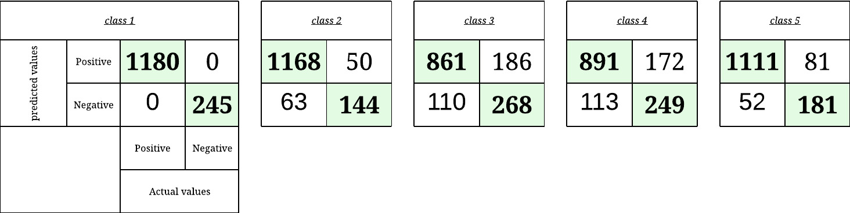

Figure . Confusion matrix of prediction per class with optimal threshold

The performance of the recommended classification model is evaluated in Figure 7. Notably, the area under the ROC curve strongly indicates the model's performance, which is roughly 0.91.

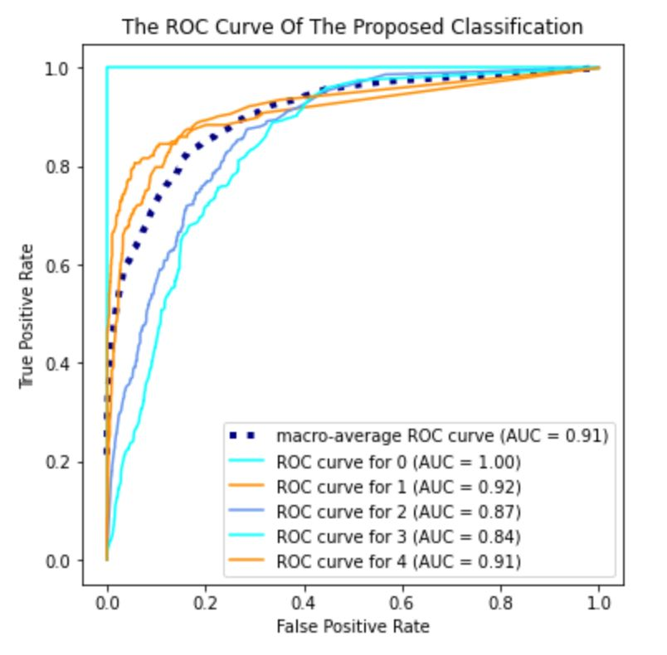

Figure . The ROC curve of the proposed classification model

In contrast to the findings in [6], this study has demonstrated the capability to forecast forthcoming user ratings for recently established dining establishments. This paper not only evaluates the ambiance of these establishments but also predicts their food delivery scores. Furthermore, a detailed examination of the user ratings is presented in restaurants that do not provide food delivery services. This analysis examines how these ratings affect the predicted outcomes.

# Conclusion

Recommender systems enhance the audience's experience and the institution's income in various scenarios. This paper utilizes a 5-star rating system and predicts the aggregated ratings of customers. To achieve this, the data undergoes preprocessing and augmentation using K-means and hierarchical clustering algorithms. Subsequently, SMOTE and SFS are employed as oversampling and feature selection techniques. SFS selects eight out of the eleven features. Following this, several classification algorithms are employed to classify the dataset based on user ratings. The results reveal that...

In the age of social networks and data-driven insights, this study employed Zomato restaurant data and machine learning techniques to shed light on the complex relationship between restaurant attributes and customer evaluations. The research considerably increased classification accuracy through the use of data preprocessing, clustering, and oversampling, with the Random Forest approach emerging as a standout performer at 88%. Notably, the study's acknowledgment of misclassifications as actual occurrences, particularly in surrounding classes, led to a stunning 96% accuracy improvement. Beyond its technical benefits, this research acts as a resource for diners and restaurant proprietors, encouraging a deeper understanding of dining preferences and paving the way for more informed decisions when pursuing wonderful culinary experiences. The study's identification of dining misclassifications as actual occurrences.

It is known that an algorithm in an intelligent system needs more parameters, such as service speed, food volume, etc., to work better. Of course, eating in various locations can have different effects due to cultural differences.

# References

[1] T. Dirsehan and E. Cankat, "Role of mobile food-ordering applications in developing restaurants’ brand satisfaction and loyalty in the pandemic period," *Journal of Retailing and Consumer Services,* vol. 62, p. 102608, 2021.

[2] J. A. Konstan and J. Riedl, "Recommender systems: from algorithms to user experience," *User modeling and user-adapted interaction,* vol. 22, no. 1, pp. 101-123, 2012.

[3] S. Kumar, B. Hooi, D. Makhija, M. Kumar, C. Faloutsos, and V. Subrahmanian, "Rev2: Fraudulent user prediction in rating platforms," in *Proceedings of the Eleventh ACM International Conference on Web Search and Data Mining*, 2018, pp. 333-341.

[4] P. Liu and E. C.-Y. Tse, "Exploring factors on customers’ restaurant choice: an analysis of restaurant attributes," *British Food Journal,* 2018.

[5] T. Limsarun, A. Navavongsathian, B. Vongchavalitkul, and N. Damrongpong, "Factors Affecting Consumer's Loyalty in Food Delivery Application Service in Thailand," *The Journal of Asian Finance, Economics, and Business,* vol. 8, no. 2, pp. 1025-1032, 2021.

[6] N. F. AL-Bakri, A. F. Al-zubidi, A. B. Alnajjar, and E. Qahtan, "Multi label restaurant classification using support vector machine," *Periodicals of Engineering and Natural Sciences,* vol. 9, no. 2, pp. 774-783, 2021.

[7] M. N. Varatharajan, J. Guruprasad, and K. Mathumitha, "Restaurant Recommendation System Using Machine Learning," *International Educational Applied Research Journal,* vol. 4, no. 3, pp. 1-4, 2020.

[8] H. H. Abdelhamied, "Customers' perceptions of floating restaurants in Egypt," *Anatolia–An International Journal of Tourism and Hospitality Research,* vol. 22, no. 01, pp. 1-15, 2011.

[9] M. R. Jalilvand, S. Salimipour, M. Elyasi, and M. Mohammadi, "Factors influencing word of mouth behaviour in the restaurant industry," *Marketing Intelligence & Planning,* 2017.

[10] K. Annaraud and K. Berezina, "Predicting satisfaction and intentions to use online food delivery: What really makes a difference?," *Journal of Foodservice Business Research,* vol. 23, no. 4, pp. 305-323, 2020.

[11] J. Ha and S. S. Jang, "Effects of service quality and food quality: The moderating role of atmospherics in an ethnic restaurant segment," *International journal of hospitality management,* vol. 29, no. 3, pp. 520-529, 2010.

[12] Y. Namkung and S. Jang, "Does food quality really matter in restaurants? Its impact on customer satisfaction and behavioral intentions," *Journal of Hospitality & Tourism Research,* vol. 31, no. 3, pp. 387-409, 2007.

[13] K. Ryu and H. Han, "Influence of the quality of food, service, and physical environment on customer satisfaction and behavioral intention in quick-casual restaurants: Moderating role of perceived price," *Journal of Hospitality & Tourism Research,* vol. 34, no. 3, pp. 310-329, 2010.

[14] D. Suhartanto, M. Helmi Ali, K. H. Tan, F. Sjahroeddin, and L. Kusdibyo, "Loyalty toward online food delivery service: the role of e-service quality and food quality," *Journal of foodservice business research,* vol. 22, no. 1, pp. 81-97, 2019.

[15] J. M. Sulek and R. L. Hensley, "The relative importance of food, atmosphere, and fairness of wait: The case of a full-service restaurant," *Cornell Hotel and Restaurant Administration Quarterly,* vol. 45, no. 3, pp. 235-247, 2004.

[16] S.-S. Cha and B.-K. Seo, "The effect of food delivery application on Customer Loyalty in Restaurant," *Journal of Distribution Science,* vol. 18, no. 4, pp. 5-12, 2020.

[17] M. Haghighi, A. Dorosti, A. Rahnama, and A. Hoseinpour, "Evaluation of factors affecting customer loyalty in the restaurant industry," *African Journal of Business Management,* vol. 6, no. 14, pp. 5039-5046, 2012.

[18] Z. Zhang, Q. Ye, Z. Zhang, and Y. Li, "Sentiment classification of Internet restaurant reviews written in Cantonese," *Expert Systems with Applications,* vol. 38, no. 6, pp. 7674-7682, 2011.

[19] Y. Luo and X. Xu, "Predicting the helpfulness of online restaurant reviews using different machine learning algorithms: A case study of yelp," *Sustainability,* vol. 11, no. 19, p. 5254, 2019.

[20] S. MEHTA. "Zomato Restaurants Data." Kaggle. <https://www.kaggle.com/datasets/shrutimehta/zomato-restaurants-data> (accessed.

[21] M. Piernik and T. Morzy, "A study on using data clustering for feature extraction to improve the quality of classification," *Knowledge and Information Systems,* vol. 63, no. 7, pp. 1771-1805, 2021.

[22] F. Nielsen, "Hierarchical clustering," in *Introduction to HPC with MPI for Data Science*: Springer, 2016, pp. 195-211.

[23] A. Moore, "K-means and Hierarchical Clustering," ed: USA, 2001.

[24] Z. Yu, Q. Wang, Y. Fan, H. Dai, and M. Qiu, "An improved classifier chain algorithm for multi-label classification of big data analysis," in *2015 IEEE 17th International Conference on High Performance Computing and Communications, 2015 IEEE 7th International Symposium on Cyberspace Safety and Security, and 2015 IEEE 12th International Conference on Embedded Software and Systems*, 2015: IEEE, pp. 1298-1301.

[25] R. L. Thorndike, "Who belongs in the family," in *Psychometrika*, 1953: Citeseer.

[26] G. Lemaître, F. Nogueira, and C. K. Aridas, "Imbalanced-learn: A python toolbox to tackle the curse of imbalanced datasets in machine learning," *The Journal of Machine Learning Research,* vol. 18, no. 1, pp. 559-563, 2017.

[27] N. V. Chawla, K. W. Bowyer, L. O. Hall, and W. P. Kegelmeyer, "SMOTE: synthetic minority over-sampling technique," *Journal of artificial intelligence research,* vol. 16, pp. 321-357, 2002.

[28] G. Douzas and F. Bacao, "Effective data generation for imbalanced learning using conditional generative adversarial networks," *Expert Systems with Applications,* vol. 91, pp. 464-471, 2018.

[29] H. Liu, "Feature Selection," in *Encyclopedia of Machine Learning*, C. Sammut and G. I. Webb Eds. Boston, MA: Springer US, 2010, pp. 402-406.

[30] S. Solorio-Fernández, J. A. Carrasco-Ochoa, and J. F. Martínez-Trinidad, "A review of unsupervised feature selection methods," *Artificial Intelligence Review,* vol. 53, no. 2, pp. 907-948, 2020.

[31] T. K. Ho, "Random decision forests," in *Proceedings of 3rd international conference on document analysis and recognition*, 1995, vol. 1: IEEE, pp. 278-282.

[32] L. Breiman, "Random forests," *Machine learning,* vol. 45, no. 1, pp. 5-32, 2001.

[33] J. A. Hanley and B. J. McNeil, "The meaning and use of the area under a receiver operating characteristic (ROC) curve," *Radiology,* vol. 143, no. 1, pp. 29-36, 1982.

[34] M. Grandini, E. Bagli, and G. Visani, "Metrics for multi-class classification: an overview," *arXiv preprint arXiv:2008.05756,* 2020.

[35] J. Cohen, "A coefficient of agreement for nominal scales," *Educational and psychological measurement,* vol. 20, no. 1, pp. 37-46, 1960.

[36] S. Collazo, M. Barrucand, and M. Rusticucci, "Association between El Niño and extreme temperatures in southern South America in CMIP5 models. Part 1: model evaluation in the present climate," *Climate Research,* vol. 83, pp. 111-132, 2021.